Name: ______________________________________________ Date: __________________ Hour: ________

**Unit 2 Test Explorers Study Guide**

**Learning Target A2.3:** *I can explain the consequences of European Exploration.*

1. How were Native Americans affected by European exploration (be specific, more than a few words)?
2. Explain the Northwest Passage (what was it, who was looking for it, why)?
3. Who conquered the Aztec, Inca, and Maya (be specific)?
4. How did the Conquistadors’ success affect European exploration?
5. Which European settlers developed the best relations with the Native Americans AND how was their approach different from that of other countries?
6. How did exploration affect Africans (be specific, more than a few words)?

**Turn to the back to finish.**

**Learning Target A2.1:** *I can identify on a map the areas of the New World claimed by each European superpower.*

1. On the map, label the lands claimed by each of the following:

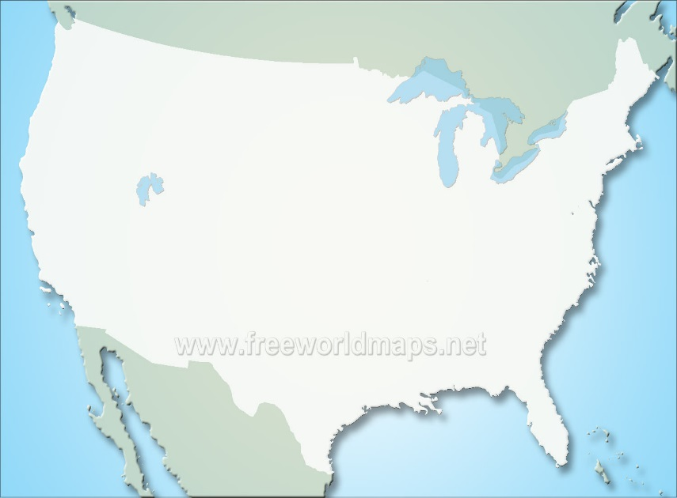

* Spain
* The Netherlands (Dutch)
* France

**Learning Target A2.2:** *I can explain the consequences of European exploration.*

1. What are the three main reasons for exploration AND define each.
2. Pick ONE of the two options:

**Option 1**: What do you believe was the most compelling reason for early European exploration? In at least three complete sentences, provide examples(s) to prove your claim.

**Option 2**: In what ways are people around the world still exploring today AND what are their modern-day motivations for that exploration? Please explain and provide specific examples in three or more sentences.