Name: ___________________________________________ Date: ____________________ Hour: __________
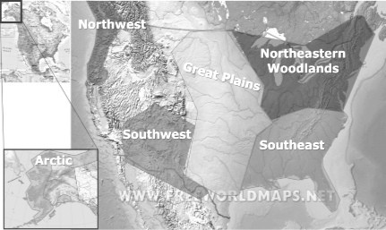
Native American Regions (Standards A1.1 – A1.4)
Remember, while we often refer to
“the Native Americans,” each group was actually its own nation. Each nation was separate. Many nations shared a similar culture because of the environments in which they lived. These similar cultures are called Native American regions.
Region Name  Example Nations | Describe the Environment | Shelter  (Type of Home) | Resources  (food, clothing, etc) | Other Interesting
Arctic
Inuit, Aleut
Northeastern Woodland
Iroquois, Algonquin
Southeast
Chickasaw, Creek, Cherokee, Seminole
Great Plains
Cheyenne, Apache, Pawnee
Southwest
Navajo, Hopi
Northwest
Chinook, Kwakiutl

