Name: _______________________________________________ Date: __________________ Hour: ________
Unit 1 Native Americans Study Guide

Multiple Choice: Be able to answer the following questions:
- What is culture?
- Although history tends to refer to all native people as “the Native Americans”, each individual group was actually its own _________________________________________.
- Native Americans believed that no one person could _____________________________________.
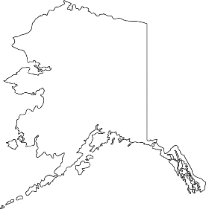
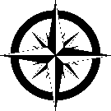

Map Identification
On the map, label the six Native American Regions.

Short Answer
Name one characteristic unique
to the Native People living in each region (because of the environment in which they lived).
- Arctic: _________________________________________________________________________________
- Great Plains: ____________________________________________________________________________
- Northeastern Woodlands: _________________________________________________________________
- Northwest: _____________________________________________________________________________
- Southeast: ______________________________________________________________________________
- Southwest: _____________________________________________________________________________
Essay: Using specific examples, please write at least three sentences describing how the geography of a region affects the lives of the people in that region.

Self-Assessment: Turn over and rate how you feel about each learning target for this unit.

UNIT 1: Native Americans Self-Assessment
Unit Learning Goal: Students will understand differences in the cultures of North American Native Peoples. | Right now, I feel my proficiency levels is:
Unit Learning Targets:
A1.1 - I can identify the Native American regions on a map.  Explain Ranking: | A | B | C | D | F
A1.2 - I can describe the characteristics of the lives of the Native Americans in each region  Explain Ranking: | A | B | C | D | F
A1.3 - I can describe common characteristics of Native Americans in the United States.  Explain Ranking: | A | B | C | D | F
A1.4 - I can describe how the geography of a specific region affected the lives of Native Americans living in that region.  Explain Ranking: | A | B | C | D | F

Assessment Proficiency Scale
A | I understand beyond proficiency on the learning standard.
B | I believe I am proficient on the learning standard.
C | I have a general understanding, but lack details required for proficiency on the learning standard
D | I am not yet able to demonstrate general understanding without help.
F | I am not yet able to demonstrate general understanding, even with help

